***Conceptual data model:***

***Entity relationship diagram :***

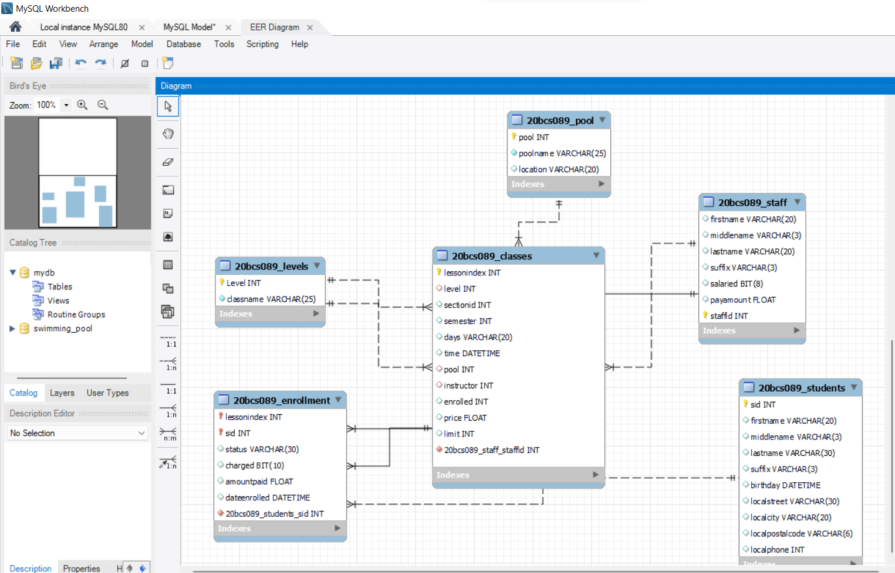

Swimming pool database entities and attributes:

# **Levels entity:** attributes are level, class name

**pool entity**: attributes are pool ,pool name, location

**staff entity :** attributes are first name, middle name, last name, suffix, salaried, pay amount

**classes entity :** attributes are lesson index , level, section id , semester , days, time , pool , instructor , limit , enrolled , price .

**students entity:** attributes are sid, first name , middle name , last name, suffix , birthday , local street, local city , local postal code , local phone

**enrolment entity:** attributes are lesson index, sid, status , charged, amount paid , date enrolled

All the relationships in the above ERD diagram are binary relationships. The

cardinality of these relationships is as follows:

• Students-Enrollment : One to Many

• Enrollment-Classes: Many to One

• Classes-Staff: Many to One

• Classes-Pool: Many to One

• Classes-Level: Many to One

As we can see from the above diagram one instructor can take many classes but

It is mandatory that each class have an instructor (from staff) while the

Participation of staff is optional i.e. it is not necessary that an instructor has a

Class assigned to him/her.

Similarly a pool can be used to conduct many classes but it is mandatory for a

Class to be conducted inside a pool. There can be a pool where no classes are

Conducted hence it’s participation in the relationship is optional.

A class has to be on some level (beginner, intermediate, advanced etc…) and there will be at least one class for every level.

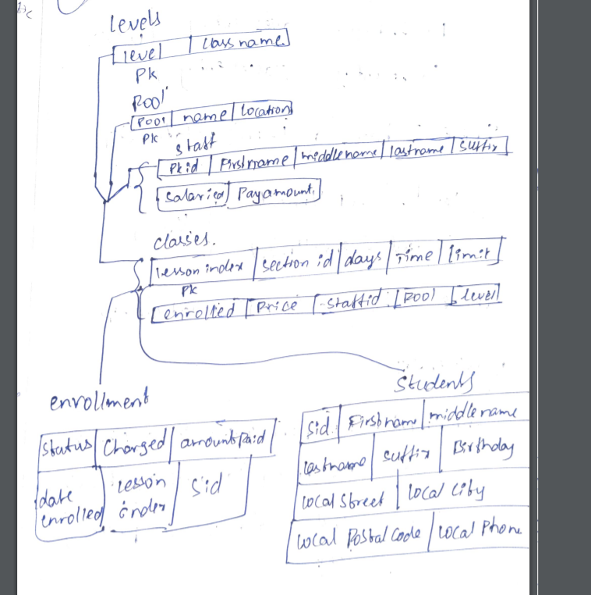

In the above diagram we can see that enrollment is a weak entity as it has no

unique primary key. One Student can enroll into many classes and many

students can enroll for the same class. So we cannot use student id or class id to

identify enrollment. So we use a composite key comprising of two foreign keys

SID and LessonIndex and assign it as the primary key. Thus we can give each

enrollment a unique id and convert it into strong entity by identifying it using

two strong entities.

Since a student has to enroll and a class must have enrolled students we can

infer that a class will have at least one student.

There can be a situation when one class is conducted more than once in a day

for the same group of students. However, due to timing conflicts, it may not be possible,that

these classes are conducted by the same instructor in different pools or by

different instructors in different pool or by different instructors in different

pools.

In any case there will be multiple records of that class with a change in

only two or three fields. This makes updating records difficult.

This can be solved by creating another entity which can be identified through a

combination of instructor id and lesson id.